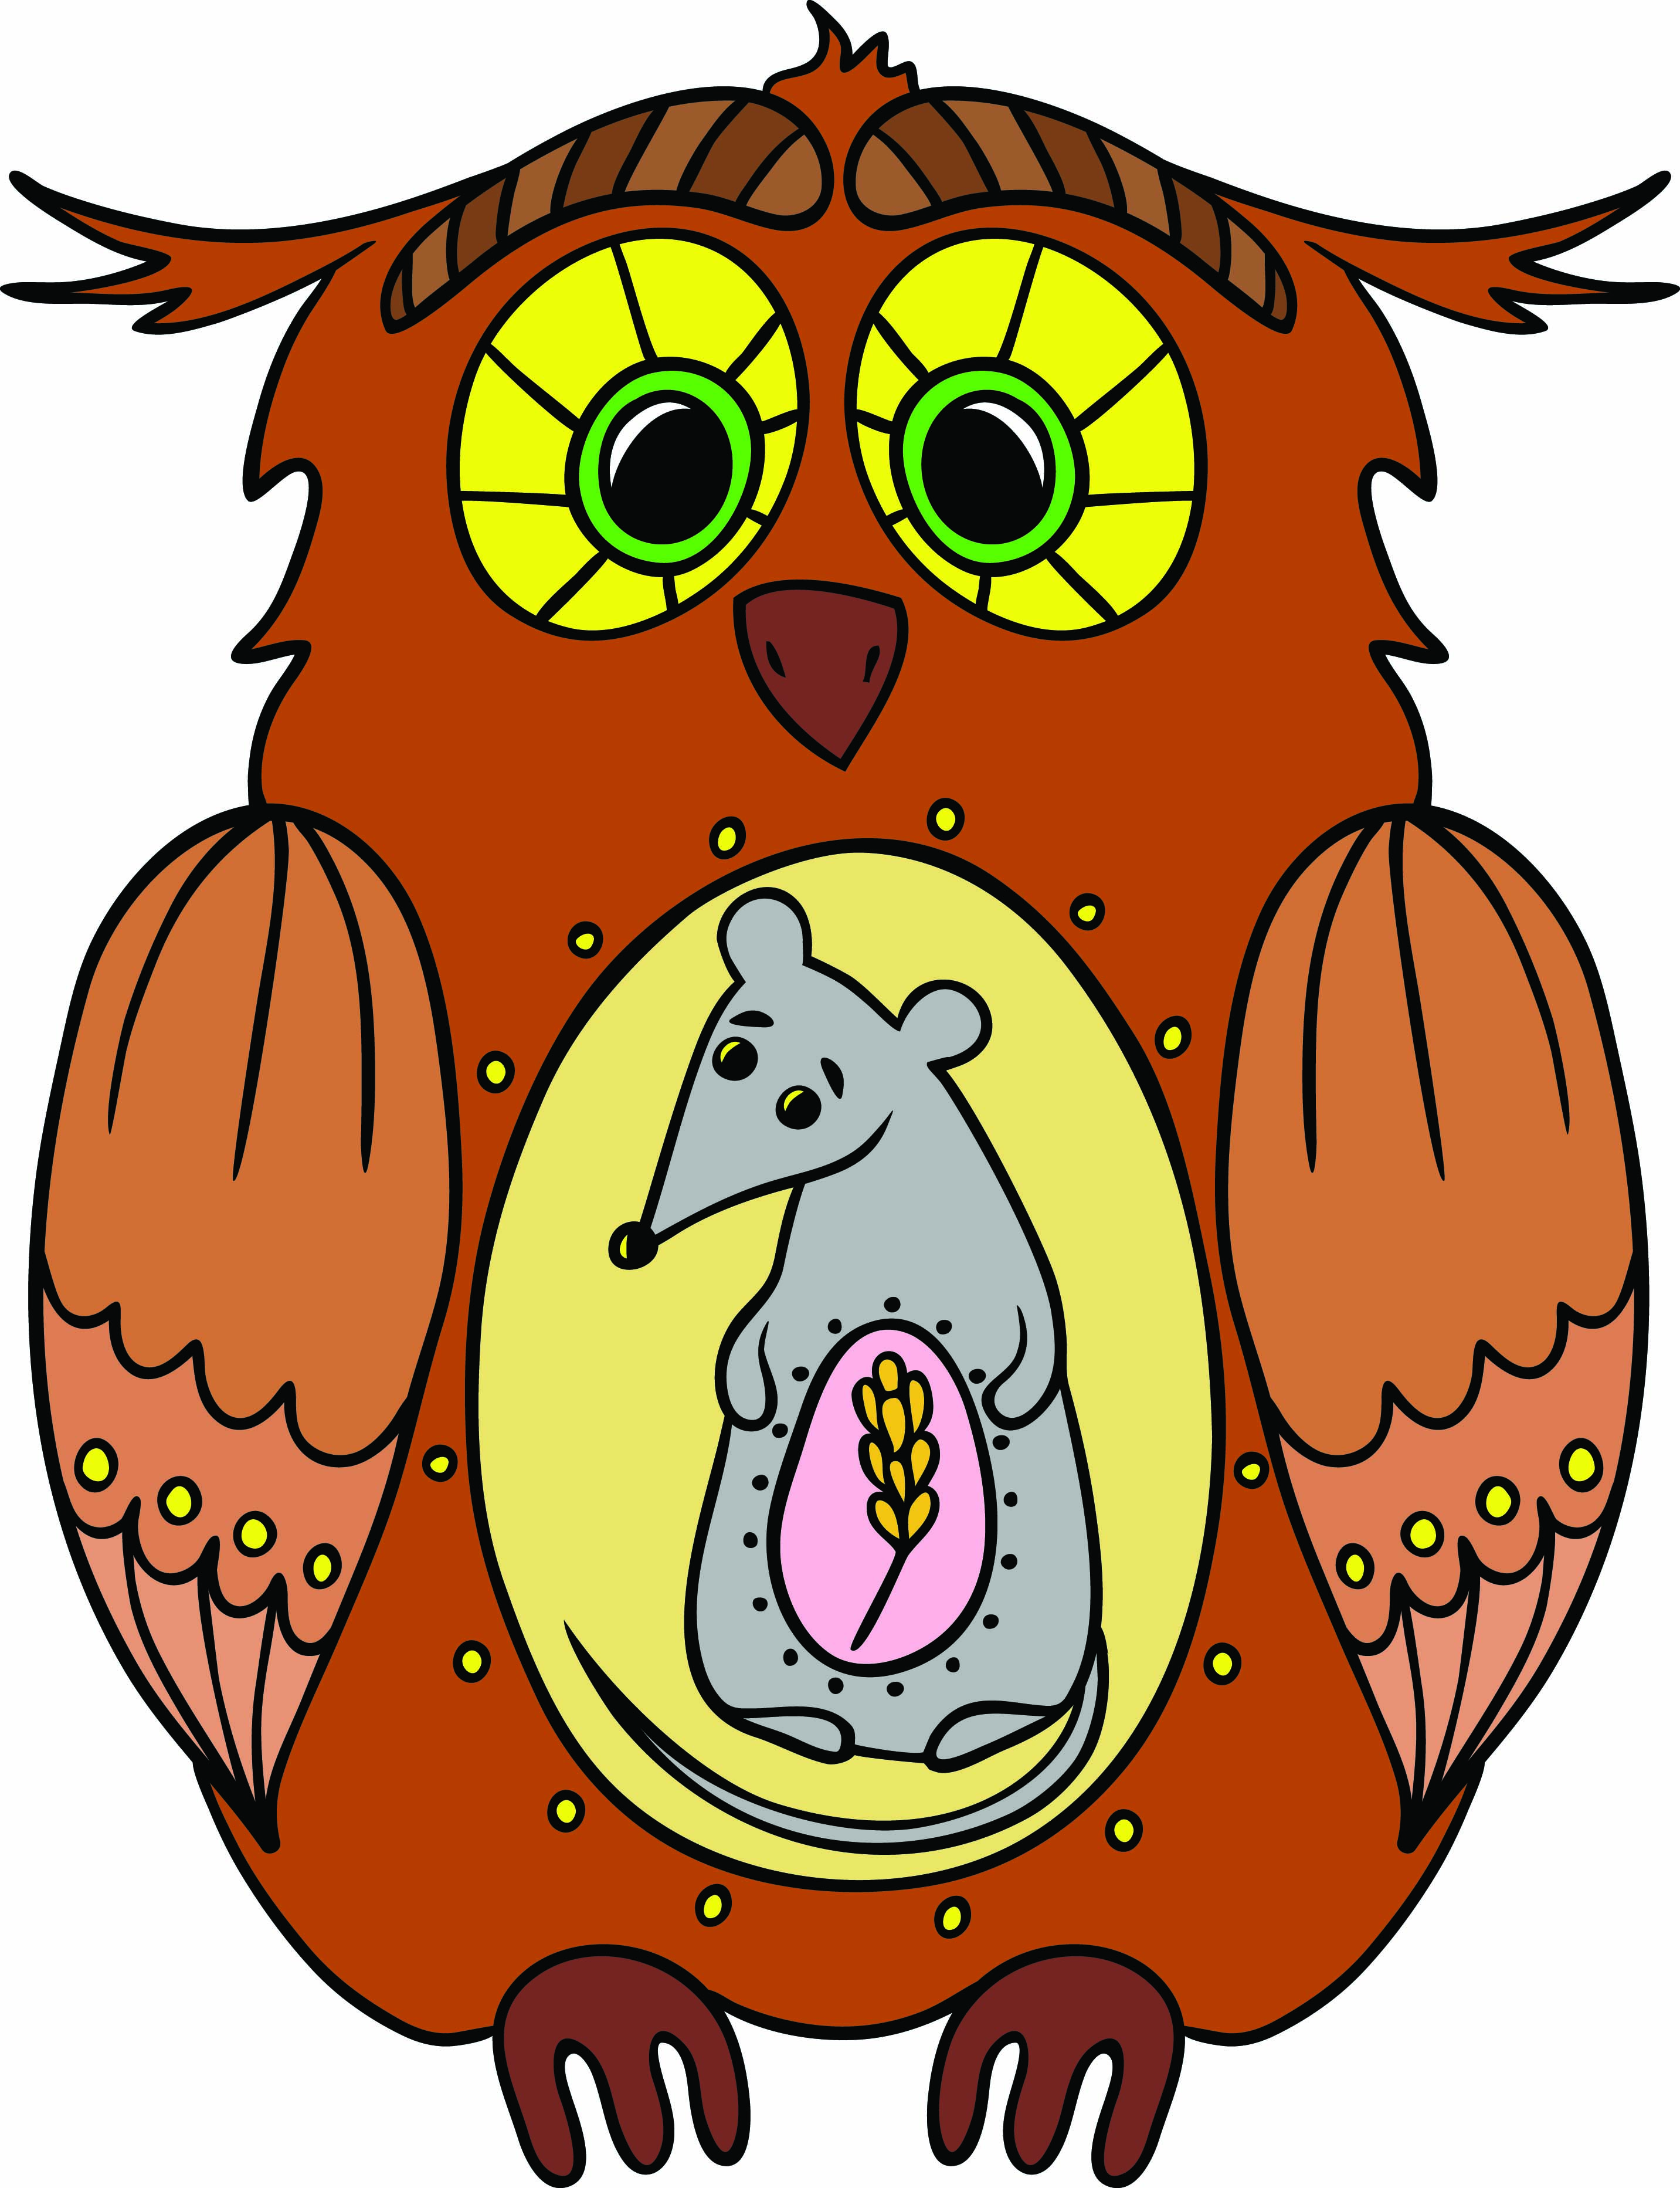Student worksheet

6.1 All organisms are interdependent

Pages 102–103 and 198

Food chains and food webs

1 Use the diagram of the owl to construct a food chain. Under each organism in the food chain, write whether they are a consumer or producer.

|  |
| --- |
|  |

The following observations were made while sitting by a billabong.

Nymphs, water beetles and fish were observed eating algae and water plants. Dragonflies were seen consuming the water beetles and nymphs. A large black swan started feeding on the water plants, but also ate the nymphs and water beetles. A long-necked turtle also ate the water plants and water beetles. Then, a huge wedged-tailed eagle swooped down and plucked the turtle from the water and started to eat it.

2 Construct a food web to show the feeding relationships between the various organisms observed by the billabong.

|  |
| --- |
|  |

a What were the producers found at the billabong?

b What were the first-order consumers found at the billabong?

c What were the top consumers found at the billabong?

d Write one food chain from the description of the billabong.

3 Could the Sun also be included in a food chain or food web?

EXTEND YOUR UNDERSTANDING

4 Research an example of a food web that does not start with the energy of the Sun.

Student worksheet

6.2 All organisms have a role in an ecosystem

Pages 104–105 and 199

Ecosystems – energy for life

1 In most ecosystems, the Sun provides the energy for the producers. The producers convert the Sun’s energy into food through a process called photosynthesis. During this process, sunlight shining on the green leaf is converted to chemical energy by chlorophyll contained in the leaves, and is then used to convert carbon dioxide and water into sugar and oxygen. Use this description to label the arrows on the diagram.

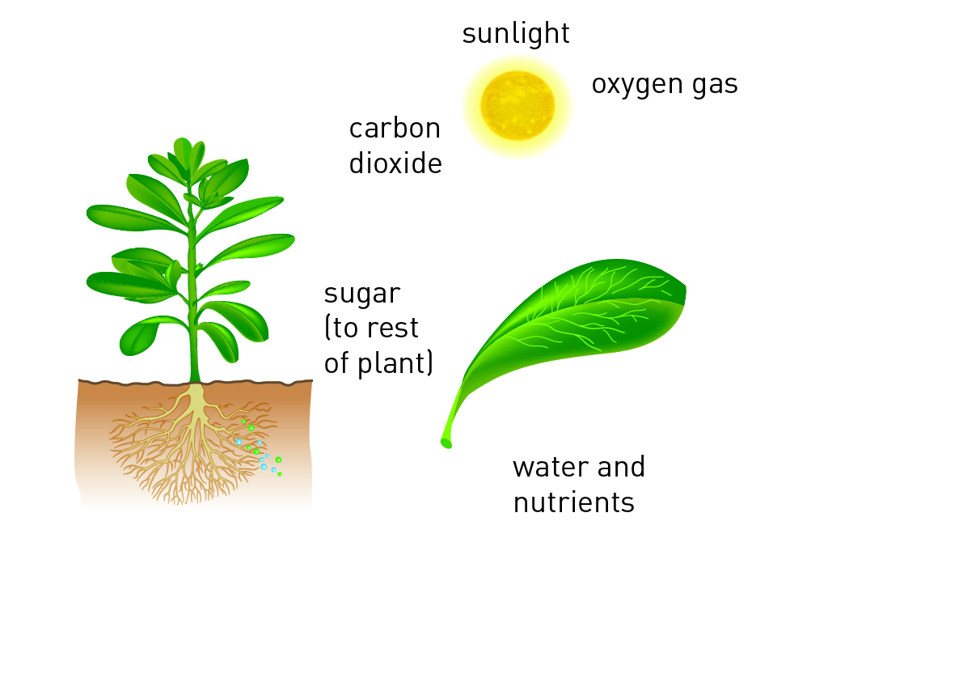

2 You may remember this description from the previous worksheet:

The following observations were made while sitting by a billabong.

Nymphs, water beetles and fish were observed eating algae and water plants. Dragonflies were seen consuming the water beetles and nymphs. A large black swan started feeding on the water plants, but also ate the nymphs and water beetles. A long-necked turtle also ate the water plants and water beetles. Then, a huge wedged-tailed eagle swooped down and plucked the turtle from the water and started to eat it.

a Which consumers are herbivores?

b Which consumers are carnivores?

c Which consumers are omnivores?

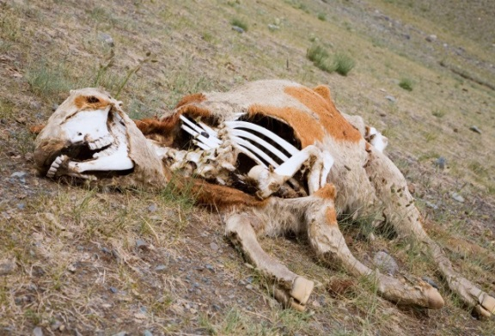

3 The cow in the image is in the process of being recycled by decomposers.

Fill in the flow chart below to show the cycle of nutrients and energy that this dead cow is part of in the ecosystem. Include the following information:

• the producer, consumers and decomposer

• carnivore and herbivore

• an example of the producer, consumer (other than the cow) and the decomposer.

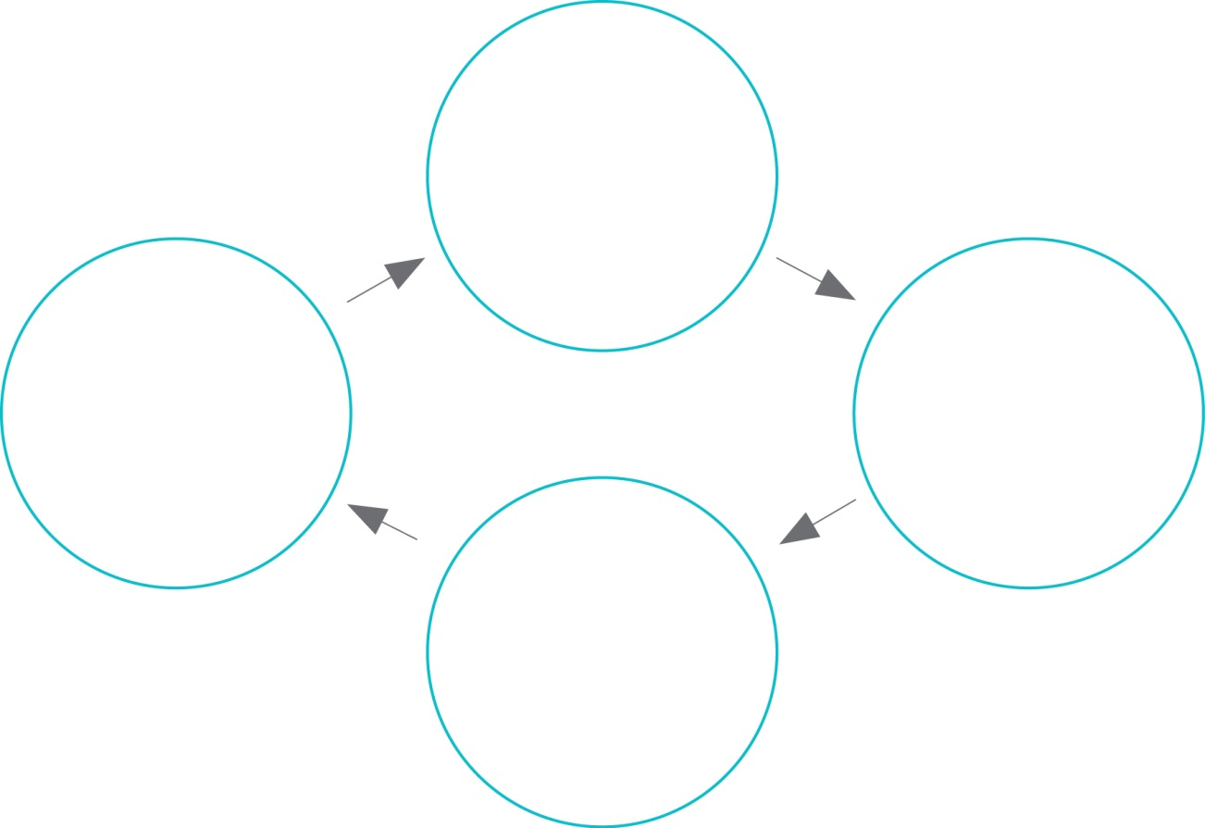

EXTEND YOUR UNDERSTANDING

4 Find out how a worm decomposes dead organisms and how this is linked to the health of the soil in a garden. The following website may be a useful place to start: <http://www.dpi.nsw.gov.au/agriculture/resources/soils/biology/earthworms>

You could present your findings as a one- to two-paragraph written response. A diagram may also be worthwhile.

Student worksheet

6.3 Food webs can be disrupted

Pages 106–107 and 200

Balance in the food web

1 You may remember this description from a previous worksheet:

The following observations were made while sitting by a billabong.

Nymphs, water beetles and fish were observed eating algae and water plants. Dragonflies were seen consuming the water beetles and nymphs. A large black swan started feeding on the water plants, but also ate the nymphs and water beetles. A long-necked turtle also ate the water plants and water beetles. Then, a huge wedged-tailed eagle swooped down and plucked the turtle from the water and started to eat it.

A year later at the same billabong, some significant changes were observed: the wedged-tailed eagle and long-necked turtle were not seen and there were significantly fewer dragonflies. However, there was a large number of European wasps flying around the billabong that were eating water beetles and nymphs, and were even attacking the dragonflies.

a Construct a food web to include the European wasps in the feeding relationships observed by the billabong. Draw the arrows in a red colour from the European wasps.

|  |
| --- |
|  |

b What organisms did the European wasps feed on?

c Which consumers would have normally eaten the organisms that the European wasps ate?

d Why do you think the long-necked turtle and the wedged-tailed eagle were not seen at the billabong?

e Were there any organisms that were predators of the European wasps?

f How do you think the European wasps may change the billabong in the future?

2 How does the loss of amphibians affect humans?

3 If 1000 frogs consume approximately 5 million invertebrates per year, how many invertebrates does each individual frog consume in:

a one year?

b one month?

c one week?

d one day?

EXTEND YOUR UNDERSTANDING

4 Different methods have been used around Australia to control the number of European wasps in the environment. One method uses another type of wasp whose scientific name is *Spechophaga vesparum*. This is a parasitic wasp.

Use the Internet to discover:

a when this parasitic wasp (*Spechophaga vesparum* ) was introduced to Australia

b how it controls the European wasp population in Australia

c whether it has been effective.

Student worksheet

6.4 Human activity can affect local habitats

Pages 108–109 and 201

Habitat destruction

1 Label the diagram of the Amazon rainforest below to summarise how human activities have affected this ecosystem. The words below can be used as a starting point, but you should try to include a little more detail too.

• The trees have been cut down for…

• The land has been cleared for…

• The river is brown because…

• The burning trees cause…

• Pollution in this area comes from

• The remaining habitat is under threat from

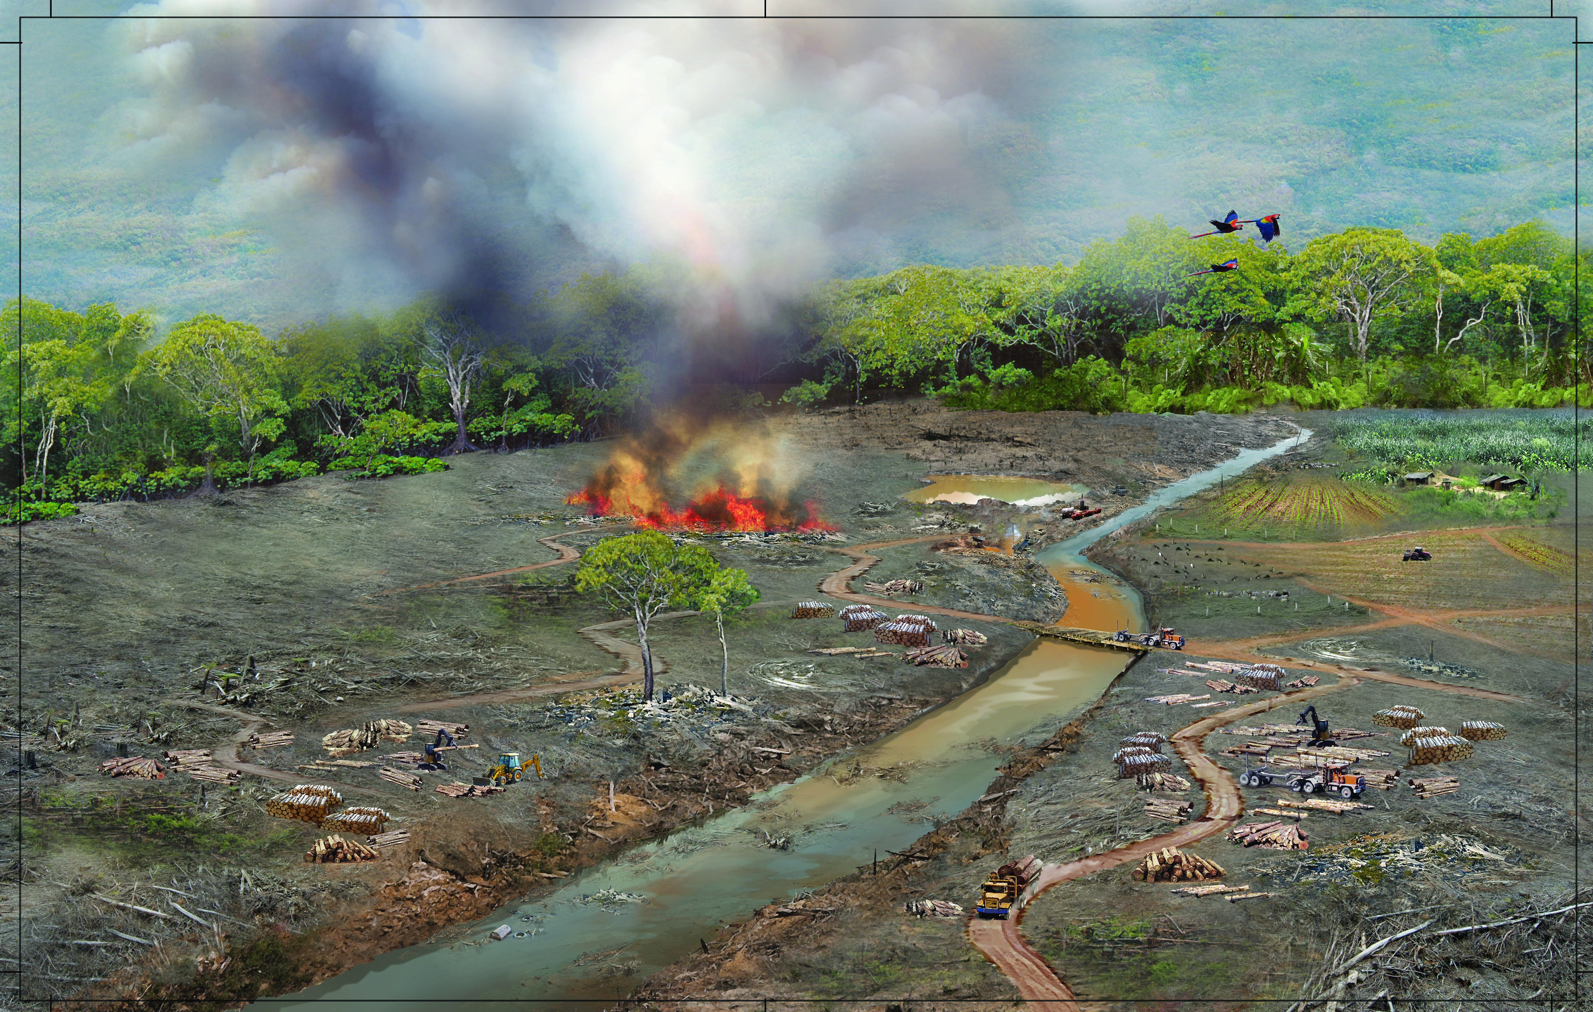

EXTEND YOUR UNDERSTANDING

2 Use your understanding of climate change and undertake further research to find out how the Amazon rainforest may change in the future.

Student worksheet

6.5 Science as a human endeavour: Isolated populations can be used as case studies

Pages 110–111

Isolated populations

1 As you can see from the image on the next page, Easter Island is not completely treeless. There are certain locations where trees have returned to the ecosystem.

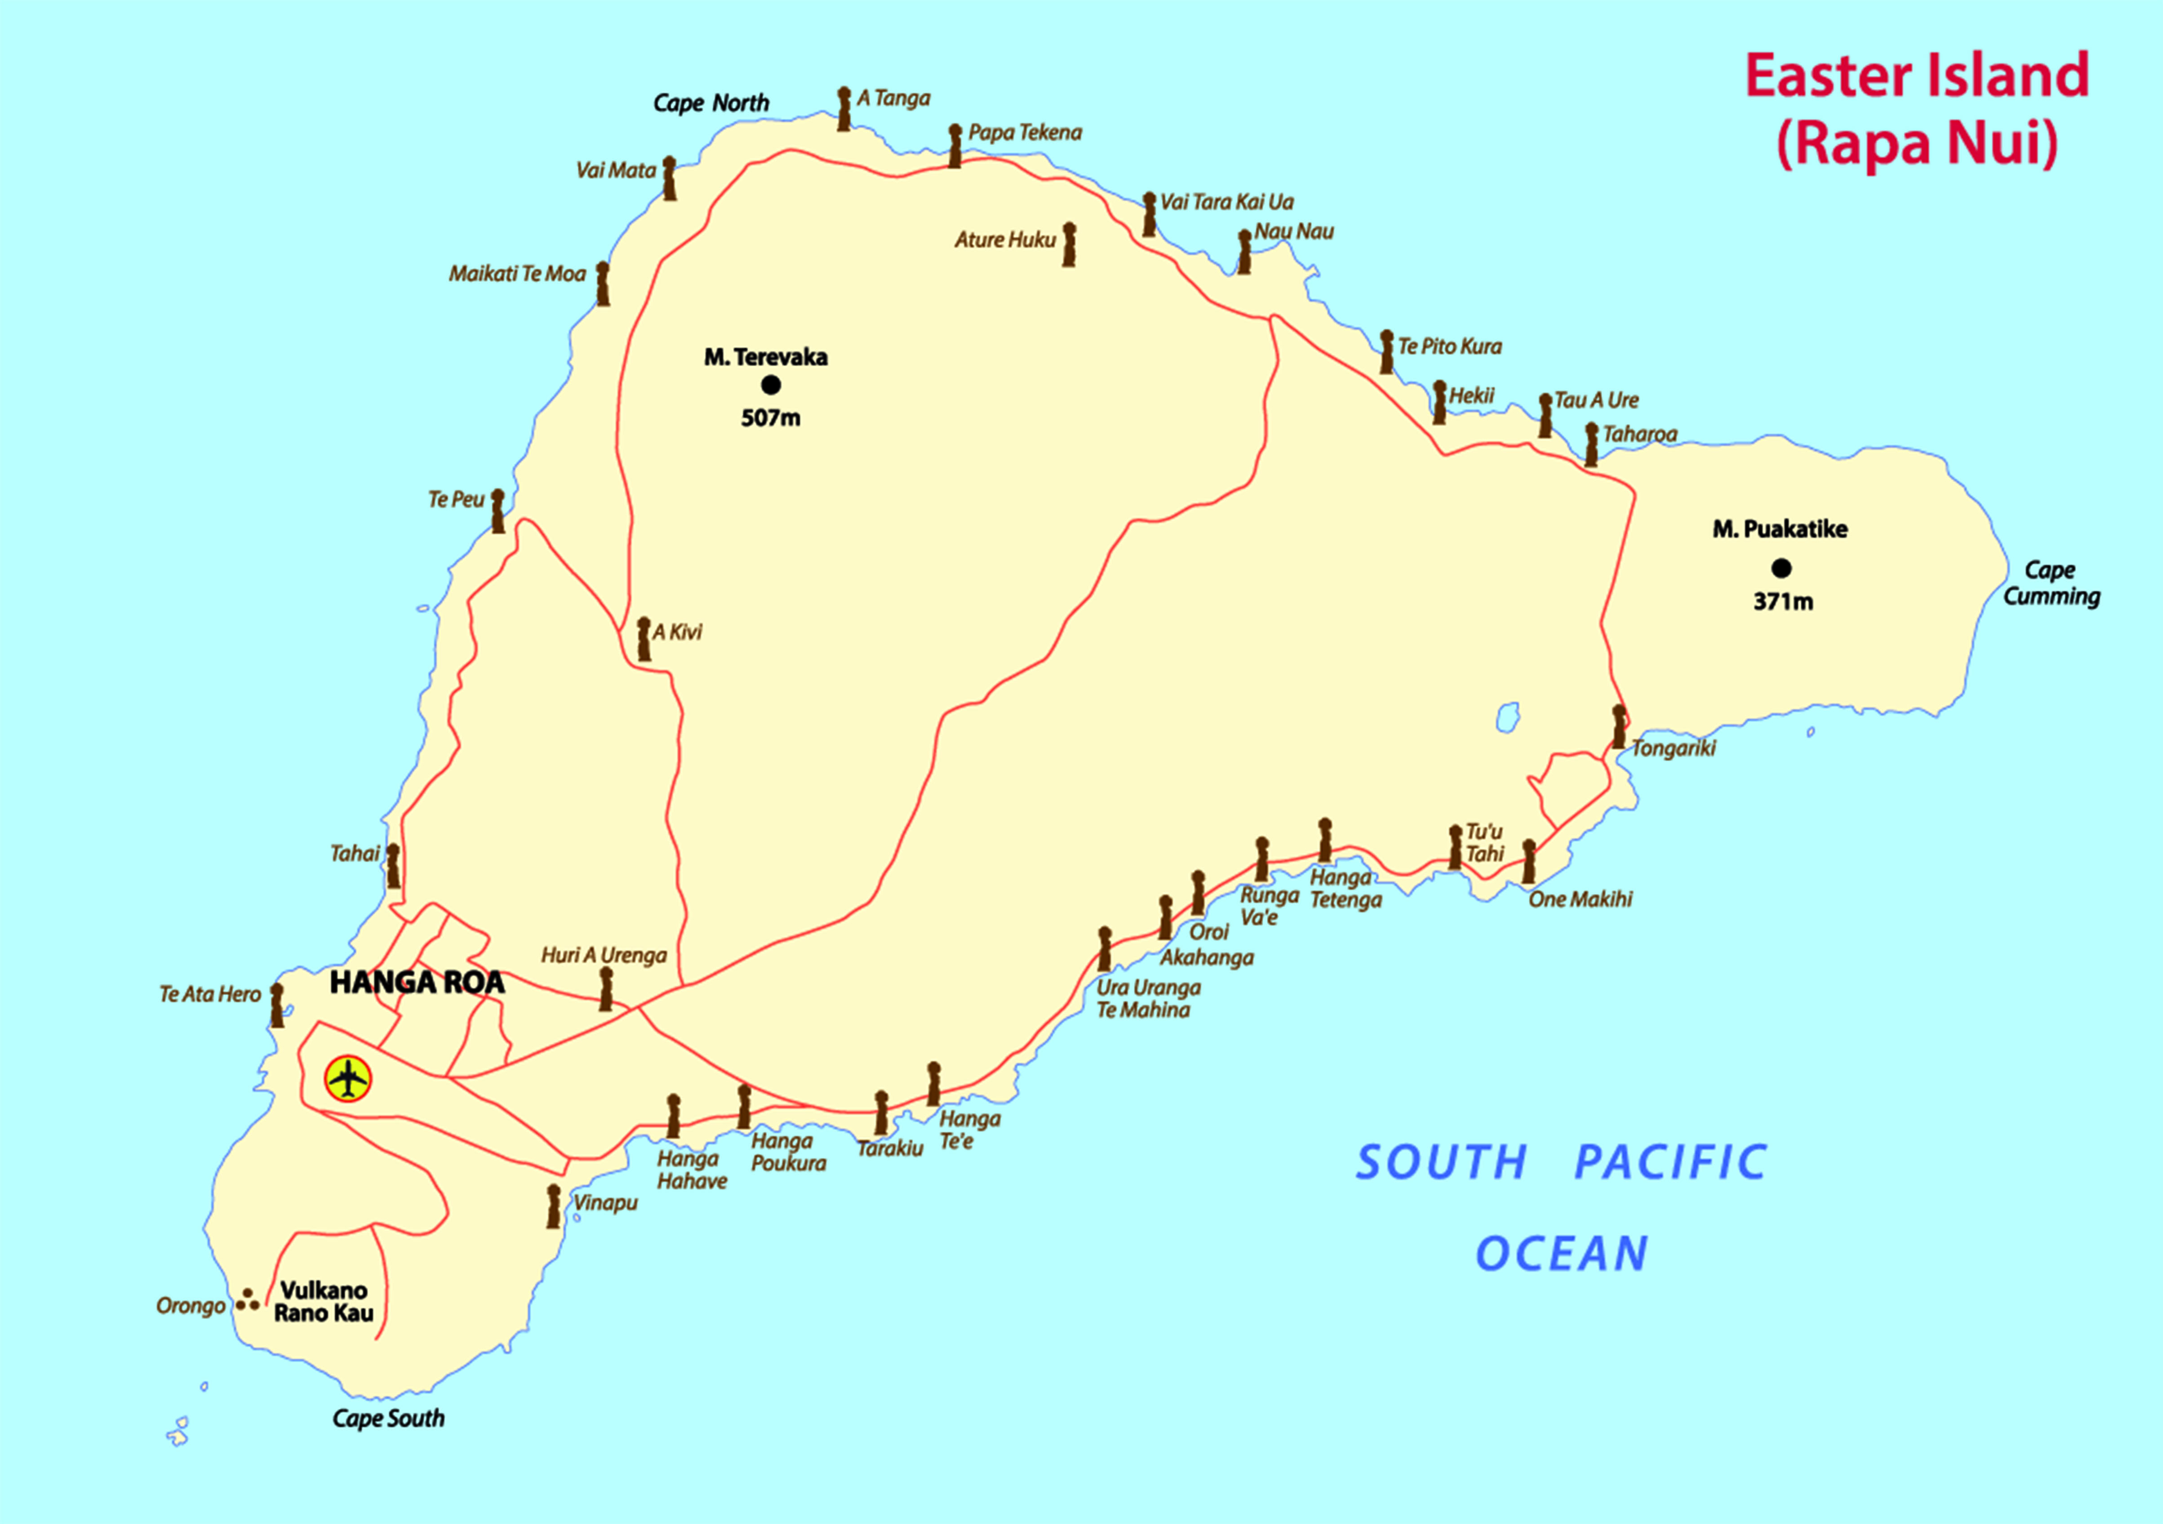

a Look carefully at the map above, especially near Hanga Roa. What evidence is there that humans live on Easter Island?

b Make an educated guess to describe how trees have returned to Easter Island.

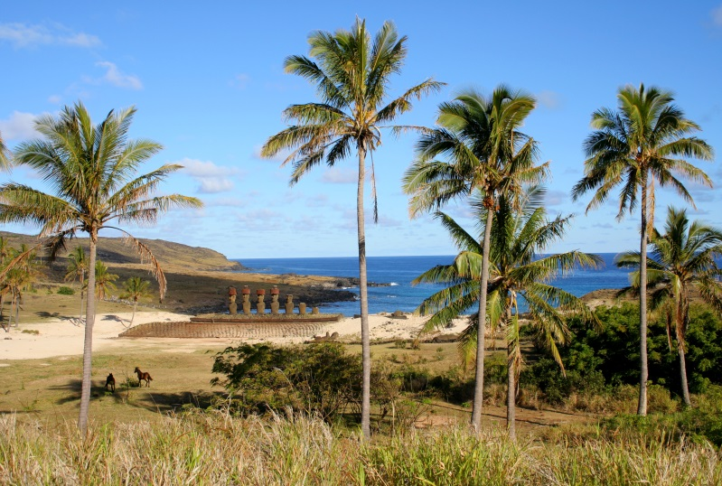

c Can you think of anyway these trees may have returned naturally to Easter Island?

d Look carefully at the photograph of Easter Island. What animals can you see?

EXTEND YOUR UNDERSTANDING

2 Research the animals and plants that exist on Easter Island and draw a food chain based on your findings.

|  |
| --- |
|  |

Student worksheet

6.6 Science as a human endeavour: Environments can be responsibly managed

Pages 112–113 and 201

Managing ecosystems

1 a What are ‘green wedges’ or ‘green belts’?

b Why are ‘green wedges’ or ‘green belts’ important?

2 a What are ‘green corridors’?

b Why are ‘green corridors’ important to animals and humans?

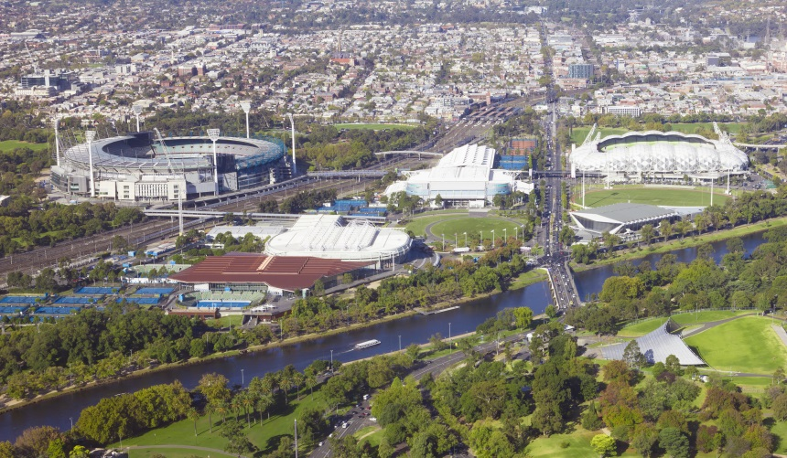3 Look at the image of the ‘sporting precinct’ of Melbourne. Describe the benefits of this ‘green wedge’ to:

a animals

b people

4 a What is a ‘seed bank’ or ‘seed vault’?

b Why is a ‘seed bank’ or ‘seed vault’ useful for the future?

EXTEND YOUR UNDERSTANDING

5 Kakadu National Park in the Northern Territory is one of Australia’s most precious ecosystems. It is home to a range of environmentally and culturally significant sites. Research some of the ways this ecosystem is managed and protected, then fill in the bubble chart below with a summary of the information you have discovered.

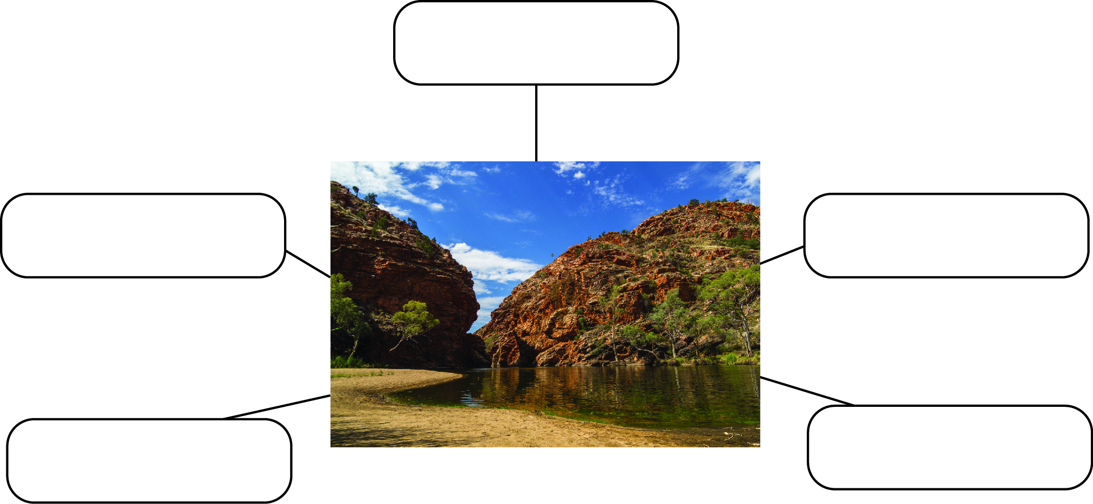

Student worksheet

6.7 Science as a human endeavour: Modern land managers use traditional Indigenous techniques

Pages 114–115 and 202

Indigenous techniques for managing ecosystems

1 Use the table below to fill in the positive and the negative effects of the firesticking farming practices of Indigenous Australians. Many of the positive effects are in the text, but you will need to also think about the negative effects.

|  |  |  |  |
| --- | --- | --- | --- |
| Effects on humans | | Effects on the ecosystem | |
| Positive | Negative | Positive | Negative |
|  |  |  |  |

2 Examine the painting below.

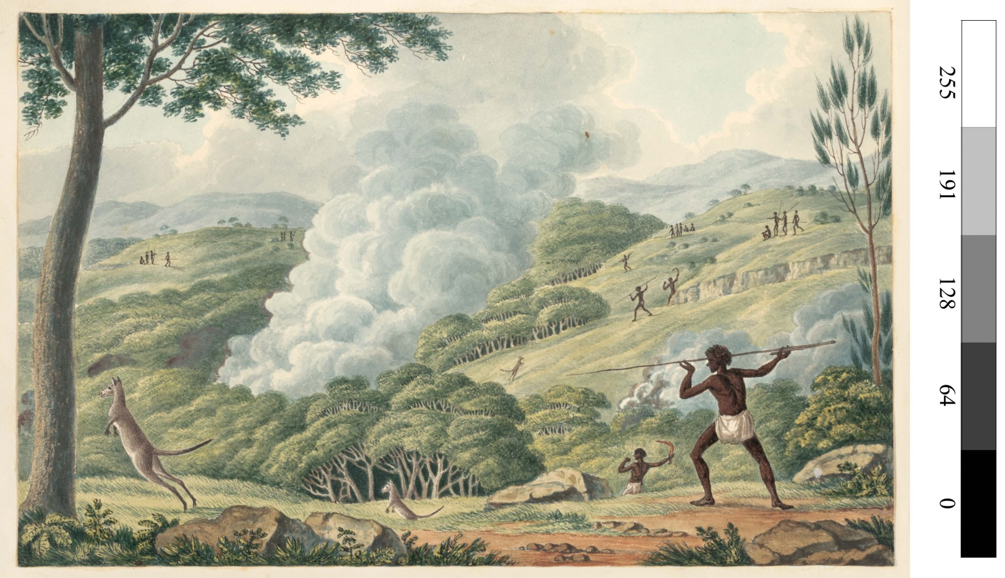

Describe the environment:

a before firestick farming.

b during firestick farming.

c one month after firestick farming.

d five years after firestick farming.

EXTEND YOUR UNDERSTANDING

3 How are eucalyptus trees able to survive bushfires? Research this and record your findings.